【例4-63】调整图像灰度值或颜色映像表
I = imread('pout.tif');
J = imadjust(I,[0.3 0.7],[]);
imshow(I)
figure, imshow(J)
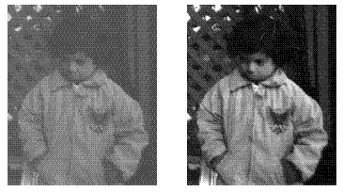
调整图像灰度值

